MPM2D Course Notes Pack Name: ___________________________________
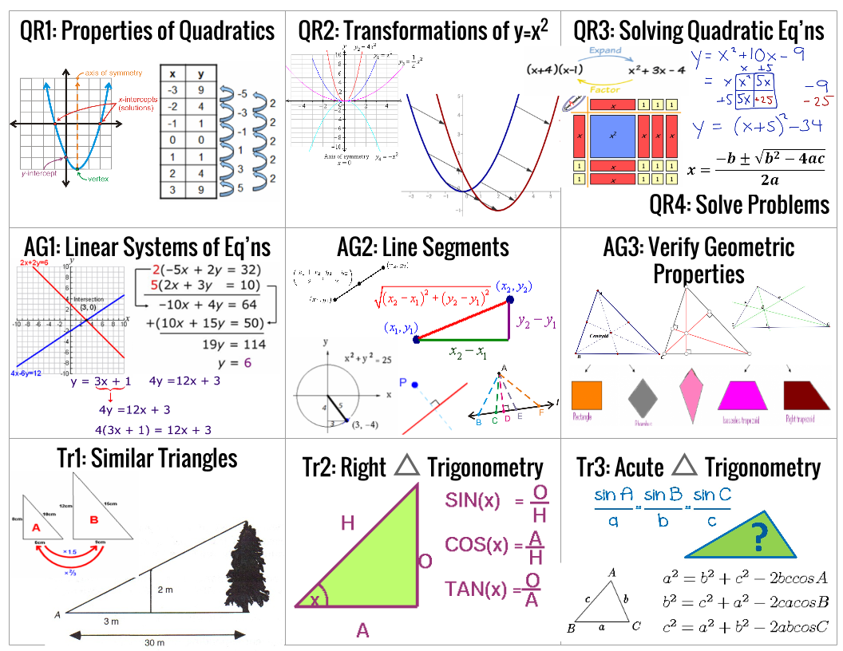
QR1: Basic Properties of Quadratics Quadratic Relations

Quadratic relation: | Second differences: | Axis of symmetry: | Determine if a relation is linear, quadratic or neither:
Standard form: | y-intercept: | x-intercepts / zeros:
Parabola: | Vertex: | Maximum/minimum:
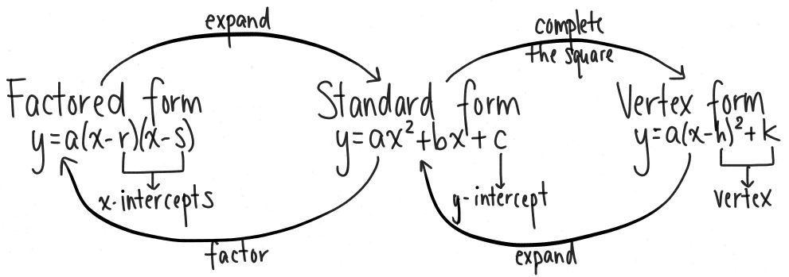
QR2: Transformations of $y=x^{2}$ Quadratic Relations

$$y=x^{2}$$ | Vertex form: | Direction of Opening:
Translation: | Reflection: | Vertical stretch/compression:

Identify the transformations that a, h, and k from the vertex form apply to $y=x^{2}$: | Identify the vertex & axis of symmetry from a graph of a parabola or its equation in vertex form:
Sketch by hand the graph of an equation in vertex form: | Determine the equation in vertex form from a given graph:

QR3: Solving Quadratic Equations Quadratic Relations

Solutions/roots: | Quadratic formula: | Discriminant:

Solve from factored form: | Solve from vertex form: | Solve from standard form:
Expand & simplify $(ax+b)(cx+d)$: | Factor  $ax^{2}+bx+c$: | Complete the square for  $ax^{2}+bx+c$:

QR4: Solving Problems using the above skills Quadratic Relations
AG1: Linear Systems Analytic Geometry

System of linear equations: | Point of Intersection:

Solve a system graphically:

Solve a system by elimination: | Solve a system by substitution:
AG2: Line Segments Analytic Geometry

Midpoint: | Equation of a circle: | Negative reciprocal: | Perpendicular bisector:

Determine the midpoint of a line segment: | Determine the length of a line segment given two end-points: | Determine the radius of a circle given its equation & sketch it:
Determine the equation of a circle given its radius & sketch it: | Determine the equation of the perpendicular bisector to a line segment: | Determine the shortest distance between a point and a line:
AG3: Verifying Geometric Properties Analytic Geometry

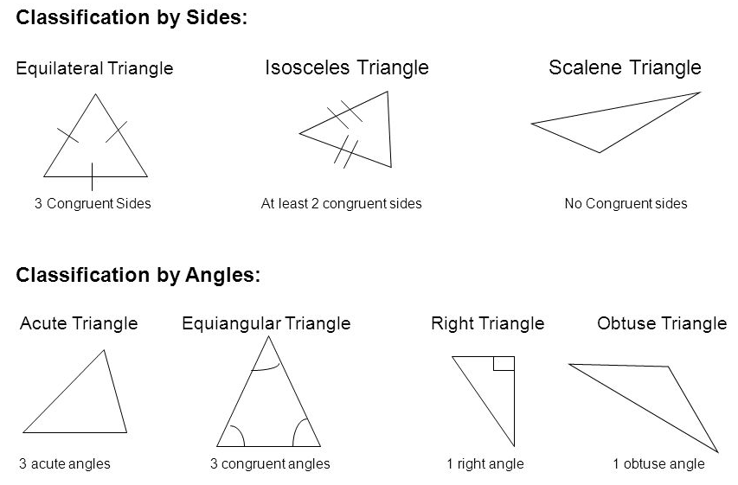

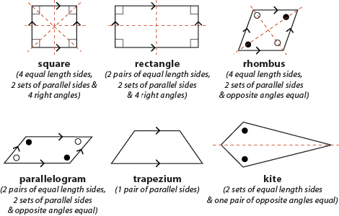
Tr1: Similar Triangles Trigonometry

Similar triangles: | Proportion: | Scale factor:

Verify properties of similar triangles: | Determine missing sides in pairs of similar triangles:
Tr2: Right Triangle Trigonometry Trigonometry

Primary trigonometric ratios: | Inverse trigonometric ratios: | Pythagorean Theorem

Theta: | Opposite side: | Adjacent side: | Hypotenuse:

Solve for missing sides using sin, cos, & tan: | Solve for missing angles using sin, cos, & tan:
Tr3: Acute Triangle Trigonometry Trigonometry

Sine law: | Cosine law:
Solve for missing sides using sine law: | Solve for missing sides using cosine law:
Solve for missing angles using sine law: | Solve for missing angles using cosine law:

