GOODY BAGS

In a week you will be hosting your birthday party. Mom has come home with all the items to make up the goody bags. You have invited four (4) friends to your party. You need to divide the loot into 5 goody bags, one for each of your friends, and one for yourself. Mom, however, did not purchase five of each item. Your task is to figure out how to divide the items into the five goody bags so that each person gets a goody bag that is fair. Your Mom has told you that when it is time to give out the goody bags she is going to hand out the bags randomly. This means that you do not know which bag you will get.

Some things to think about:
- What is fair?
- How will you justify the fairness of each goody bag to your friends?

When you have finished sorting the items for each goody bag, you must explain how you chose to sort the items for each goody bag and why this is fair.

Item | How many | Picture
Snack sized chips | 3 | 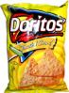
Yo-Yo | 2
Key Chain | 6 | 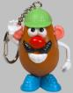
Jumbo Eraser | 3
Chocolate Bar | 7
Ring Pop | 5 | 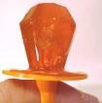
Gel Pen | 4
Sticker | 2
Calculator Cell Phone | 2 | 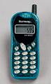
Tattoo | 6

