KINDERGARTEN SNACK SHARING

Some parents dropped off snacks for your class to share. You and two other students sit at a table. Your table is given six mini oranges and five graham crackers to share. How are you going to share them fairly?

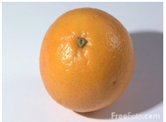

Note: Please allow scissors so students can split the crackers into two parts (if they want to).
