NINE HOLE GOLF COURSE

Prince George is getting a new 9-hole golf course, which is going to be built on a treed lot just outside of town. Your task is to come up with a layout for the golf course.

Here are a few things that the owners of the golf course would like you to keep in mind:

- must be two par-3 holes, five par-4 holes, and two par-5 holes
- a par-3 must be between 150 and 200 metres in length
- a par-4 must be between 250 and 400 metres in length
- a par-5 must be between 400 and 500 metres in length and must have a bend in it
- all fairways are between 75 and 100 metres wide
- must start and finish in the same place
- can never be two par-3 holes or two par-5 holes in a row
- pond in the middle of the property that you need to work around
- must include a clubhouse and a parking lot

To help you with your design and layout you have been provided with a scaled map of the property (every square is 50m x 50m). Present your final design on a copy of this map.
  - number the holes
  - indicate tee boxes with the letter T
  - indicate greens with the letter G
  - indicate trees that are going to be left with the letter X

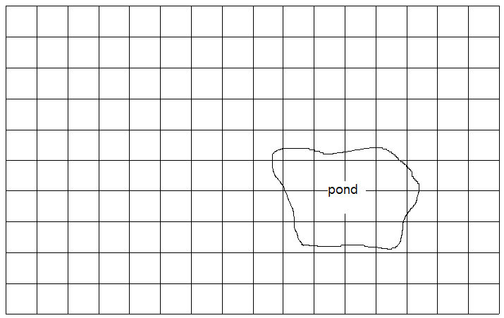

Nine Hole Golf Course – work grid

