THE NEW PUBLISHING ROOM

The school has just found an unused storage room that they want to convert into a new publishing room for the yearbook committee to work in. There are three options for how to purchase flooring for this room:

Square Tiles – each tile is 20 cm x 20 cm and costs $28 for a box of 20 tiles. Individual tiles can also be bought for $2 a piece. Unused tiles cannot be returned.

Rectangular Panels – each panel is 20 cm x 60 cm and costs $33 for a box of 8 panels. They cannot be purchased in individual panels and unused panels cannot be returned.

Sheets – each sheet is 1 m x 2 m and costs $50 each. The sheets are sold individually and unused sheets cannot be returned.

Cost is an issue! Your task is twofold:

- Determine which floor costs less.
- Prove to the principal that your choice is the best possible solution (costs less than any other proposal).

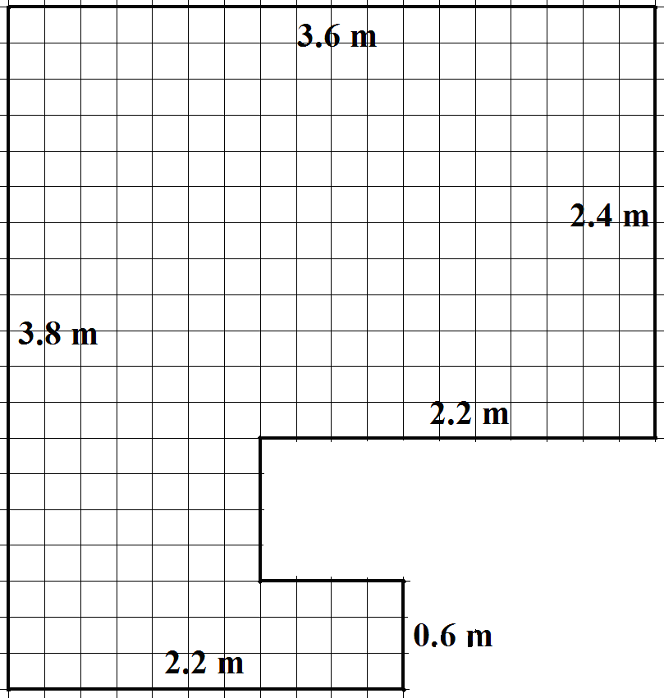

The new Publishing Room – work grids

